University of the People

MATH 1281 - Statistical Inference

Unit 1 Written Assignment 1

Liang Xiao

**Part I: Estimating a Population Proportion**

Background: A sample of 675 families in the Dominican Republic was surveyed. Out of them, 232 responded that they could not afford a $300 unexpected expense without borrowing.

**1. Define the population in this survey.**

The population is all families living in the Dominican Republic.

**2. What is the population parameter estimated in this survey?**

The parameter being estimated is the proportion of all families in the Dominican Republic who cannot afford a $300 unexpected expense without loans.

**3. What is the point estimate for the parameter?**

The point estimate is the sample proportion: ̂p = 232/675 = 0.3437

**4. What is the statistic used to measure the uncertainty of the point estimate? Compute it.**

The standard error is used to measure uncertainty. SE = sqrt[p(1 - p)/n] = sqrt[0.3437 × 0.6563 / 675] = 0.0183

**5. If the true population value is found to be 40%, would the standard error change much?**

Using p = 0.40, SE = sqrt[0.4 × 0.6 / 675] = 0.0189. This is close to the earlier SE (0.0183), showing the estimate is fairly stable.

**Part II: Constructing a Confidence Interval**

Scenario: Out of 504 randomly selected cinema viewers, 124 visited because they received a coupon.

**1. What is the sample proportion?**

̂p = 124 / 504 = 0.2460

**2. Calculate the standard error.**

SE = sqrt[p(1 - p)/n] = sqrt[0.2460 × 0.7540 / 504] = 0.0192

**3. Calculate the margin of error for a 95% confidence level.**

ME = z* × SE = 1.96 × 0.0192 = 0.0376

**4. Construct the confidence interval.**

95% CI = ̂p ± ME = [0.2084, 0.2836]

Interpretation: We are 95% confident that between 20.84% and 28.36% of all cinema visitors came because of a coupon received by mail.

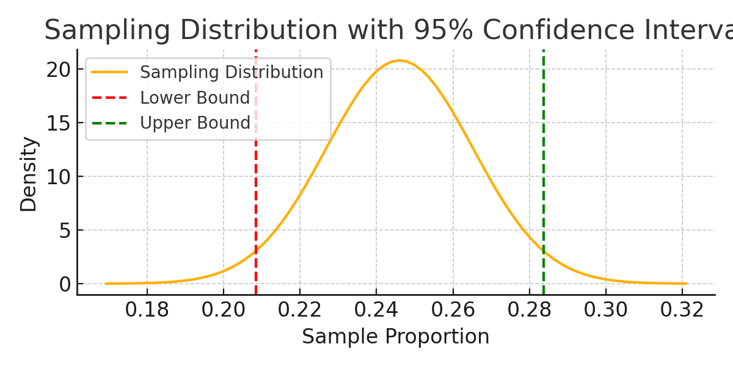

Figure: Normal distribution illustrating the 95% confidence interval.

**References**

Diez, D. M., Barr, C. D., & Çetinkaya-Rundel, M. (2019). “OpenIntro Statistics” (4th ed.). OpenIntro.

University of the People. (2025). “Unit 1: Foundations for Inference & Introduction to JASP”. UoPeople.